Please join us for the
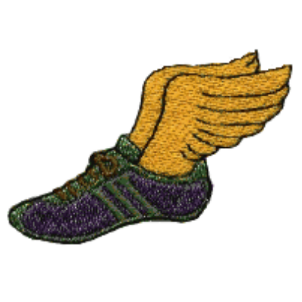


Shawnee Mission South

Track and Field

Awards Banquet

Come Celebrate All of our Athletes
Monday, May 18, 2009
6:00 p.m.
Shawnee Mission South Cafeteria
Dinner catered by Jose Peppers

Advance Reservations are required. No tickets will be sold at the door. Any questions
call Michelle White at 913-648-6223(home#) or 913-706-1076(cell#). Please send your
form below and your check no later than May 13(Deadline!!) to:

Michelle White, 9721 Eby, Overland Park, Ks. 66212

-----------------------------------------------------------------------------------------------------

ATHLETE’S NAME______________________________________

NAME(S) OF OTHERS ATTENDING_______________________
_______________________________________________________

The cost is $10.00 per person, including athletes. Please make check payable to:
SMS Track and Field Booster Club. Your check and this form ensure your
reservation.

Total number attending______ @$10.00 per meal

Amount enclosed $___________

